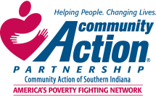
I In compliance with state and federal laws, Community Action of Sothern Indiana will not discriminate on the basis of
race, color, national origin, age, sex, veteran’s status, sexual orientation, marital status or disability or other legally
protected status.

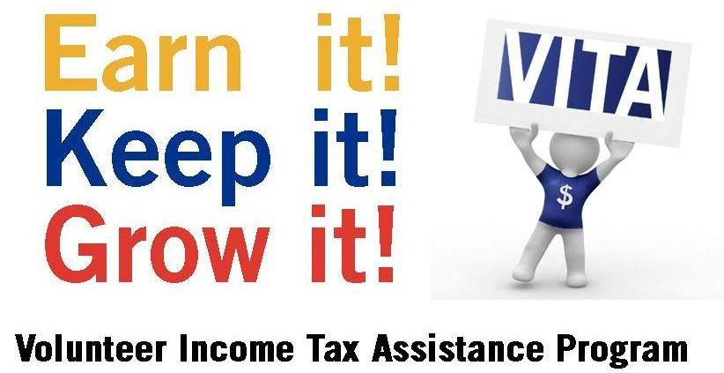
Get your taxes prepared free by IRS-certified volunteers, for Low-Income clients with income under 64,000, with Simple Return! Avoid expensive ‘rapid refund’ loans and costly tax preparation fees.
Saturday, January 27, 2024 – Saturday, April 27, 2024
SPONSORED BY COMMUNITY ACTION OF SOUTHERN INDIANA
HELP FILING TAXES ONLINE Open February 4
GetYourRefund.org/CASI
DO YOUR OWN TAXES AT
UnitedWay.org/MyFreeTaxes Income Limit $73,000
In
Income Limit $73,000

*Three Ways to File
IN PERSON AT ONE OF THE BELOW
TAX SITES
BY APPOINTMENT

What to bring:
*Picture ID and Social Security cards for everyone listed on the return
*W-2’s and 1099’s from your employers
*Other 1099’s for interest, dividends, state tax refund or other income
*1098 for education credit plus detailed financial statement from the school
*Bank account number and routing number for direct deposit
*Childcare information including Provider ID and actual amounts paid
*Summarized list of other income/expenses for those who itemize or are self employed
*Property Tax Paid on residents or rental information Receipts for Charitable contributions.
*Refund Delay for the Earned Income Tax Credit and Child Tax Credit until February so the IRS can check to see that each child is only
on one tax return
New Albany Floyd County Library
180 West Spring St. New Albany, IN
Thursdays from 1:00 PM – 4:00 PM –appointment 812 590 4064

Community Action of Southern Indiana -
201 East 15th Street, Jeffersonville, IN 47130
Saturdays 9 AM to 12 Noon
Tuesday 1 PM to 4 PM
Appointment Call 812 590 4064

Appointments Only 812 59 4064

Saturdays 9:00am – 12:00pm appointments 812 590 4064

Palmyra United Methodist Church
14170 Greene St NE
Palmyra, In 47164
Mondays and Tuesdays 2:00pm - 5:00pm
Appointment 812-590 4064

